**Adolescents – Nested table**

**Select** **a.ano , g.\***

**From** **Adolescents a, TABLE( a.Guardian) g**

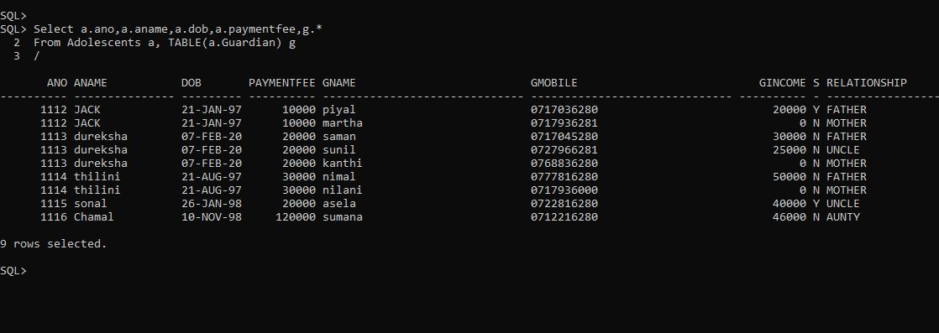/

**Doctor-table**

**select \***

**from doctor;**

/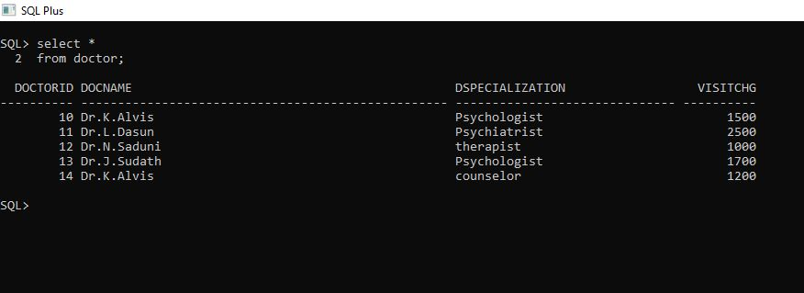

**Schedule - table**

select s.schedule_no,s.schedule_name,s.schedule_type,s.scheduled_adolescent.aname

from schedule s;

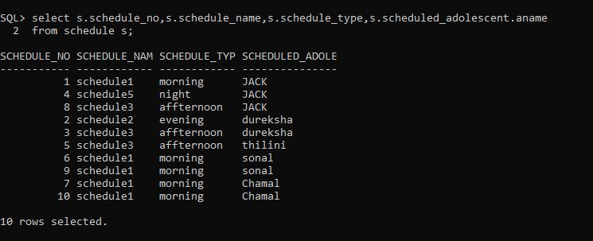

**Activity - table**

select a.activity_no,a.activity_name,a.aschedule.schedule_name,a.arate

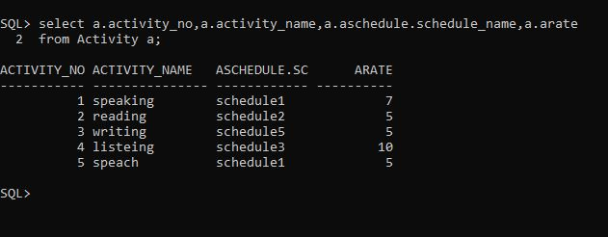from Activity a;

**medicalRecord-table**

select r.rdate,r.rAdolescent.aname,r.rdoctor.docname

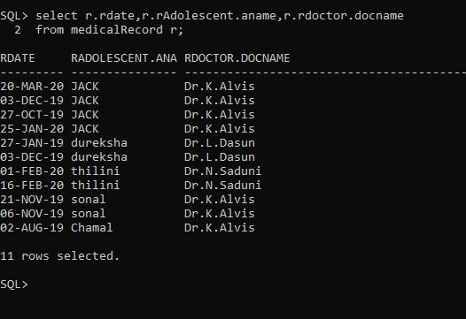from medicalRecord r;